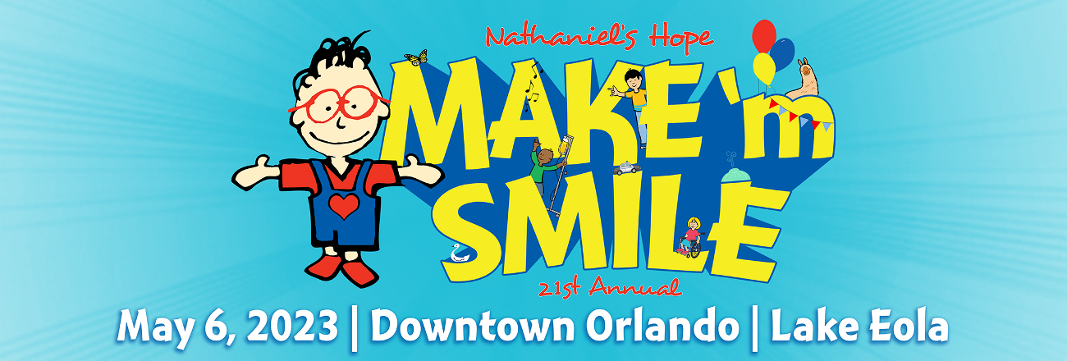

Nathaniel’s Hope Has a New Date for our 21st Annual MAKE ‘m SMILE Festival
Celebrating Kids and Adults with Special Needs (our VIPs) and Their Families

February 13, 2023, Orlando, FL – Organizers of the national Nathaniel’s Hope non-profit, and hundreds of volunteers from throughout the community, are well underway in planning the 21st MAKE ‘m SMILE party, the biggest known celebration of its kind in the world for “VIP Kids” of all ages from throughout the special needs community.

For the last 20 years, Nathaniel’s Hope held the event on the first Saturday of June, to commemorate the birthday of Nathaniel Timothy Kuck (June 6th). However, this year – to enjoy cooler temperatures and stay away from tropical storms, the 2023 party returns to the Lake Eola in downtown Orlando, on Saturday, May 6, from 8:00 am – 1:30 pm.

Festivities this year feature stage performances by individuals with varying abilities and local personalities; guest appearances of popular celebrity characters, including Nathaniel; food; and hundreds of family-friendly games, activities and over 120 resource exhibitors. Everything is free for registered VIP Kids and their families, with a minimal $5 donation for the general public.

“We’re so excited to be back at Lake Eola even sooner this year,” said Nathaniel’s Hope co-founder Marie Kuck. “We hope that moving the date up will allow for better conditions for our VIPs and all other attendees, since the heat and likelihood of tropical weather impacting us is less likely.”

A crowd of more than 30,000 party attendees are expected, including VIP kids and their families/caregivers, along with 500+ volunteers, including a mix of “buddies” from the community who walk around the lake on a designated ‘Friendship Stroll,’ to share in the experience.

In addition, over 120 vendors who service the disability community will exhibit on site, along with more than a dozen churches, and multiple new and returning corporate event sponsors. Participants will enjoy bounce houses, petting zoos, the Transportation station, Animal Land, the Party Zone, Soaked Zone, and so much more.

“MAKE ‘m SMILE is truly a major community partnership, and we appreciate all those organizations who join us to make this a day of friendships and smiles for those with varying abilities,” said Kuck. “Individuals and friends from the community are invited to be a buddy and join the Friendship Stroll, encouraging inclusion while enjoying the event.”

ABOUT NATHANIEL’S HOPE
Nathaniel’s Hope is a 501(c)(3) organization established in 2002, in honor of Nathaniel Timothy Kuck, whose parents Tim and Marie Kuck, discovered firsthand the challenges associated with raising a child with special needs. Nathaniel’s Hope celebrates special needs kids of all ages (VIPs) and their families, with the goal to educate and equip communities with tools and programs to assist kids with all types of disabilities, including physical, cognitive, medical or hidden disability, chronic-or life-threatening illness, or those who are medically fragile.

For more information about Nathaniel’s Hope, visit www.NathanielsHope.org;
for information or to volunteer for the 21st MAKE ‘m SMILE event visit www.NathanielsHope.org/our-programs/make-m-smile or call (407) 857- 8224.

###

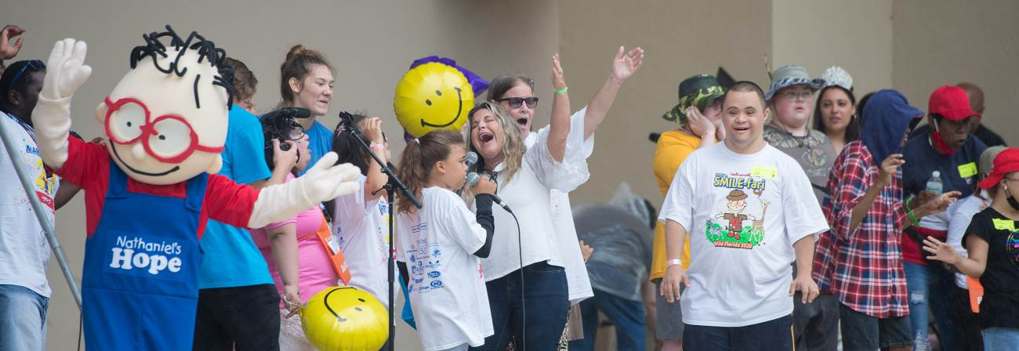

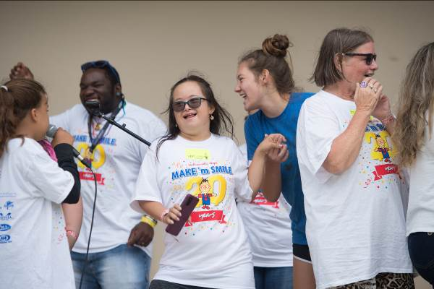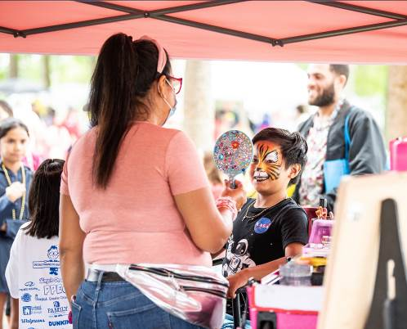

Caption: The 21st MAKE ‘m SMILE festival will be held May 6 at Lake Eola, hosted by Nathaniel’s Hope to celebrate Kids and Adults with disabilities (VIPs) and their families!

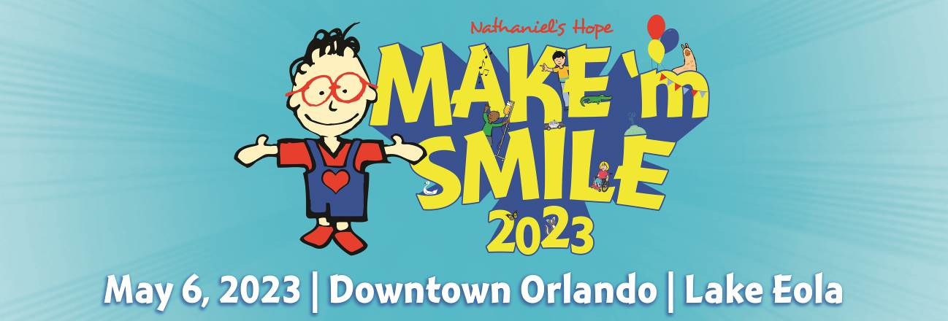

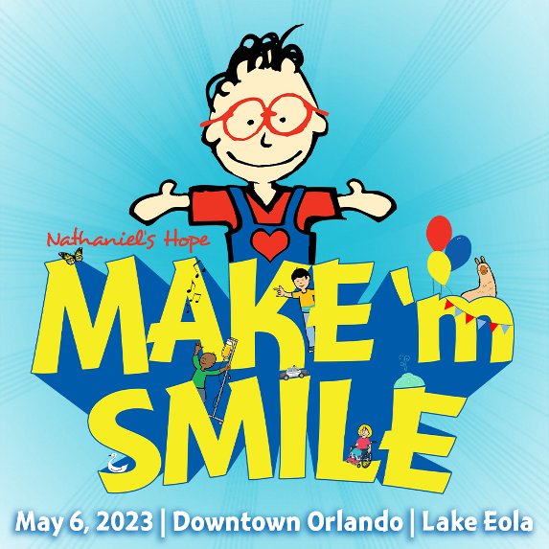
SOCIAL MEDIA POST: The world’s biggest known party celebrating VIP Kids of all ages with special needs and their families, is coming May 6 to Lake Eola! Join the fun and festivities featuring food, games, exhibits, a friendship stroll, live performances and more! Sponsors and volunteers are needed!
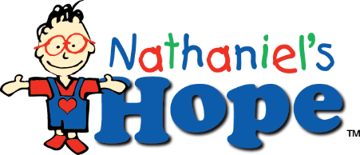
INFO: https://nathanielshope.org/our-programs/make-m-smile/make-m-smile-orlando/ or call (407) 857- 8224.

