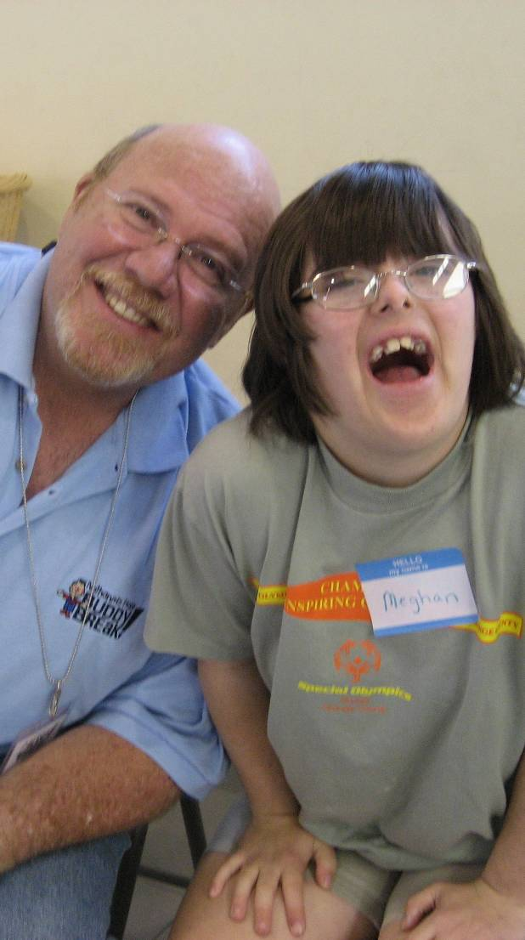  hope  “Buddy Break is such a gift for  my family! My kids have found a place where they fit right in, are cared for, and loved in ways that sometimes I, as an exhausted mom, just can’t do. My son with special needs has a wonderful time playing with his Buddy and his sibling gets to talk to other children “like me, with a special brother or sister.” Meanwhile, I have time to get a few things done, reconnect with friends, or even just sit still with a sense of peace so that I can be a stronger and better parent. Thank you so much for all you do. I am incredibly grateful!”  ~ Lucette, VIP Parent |   Grace Baptist Church  204 SW 11th Place  Cape Coral, FL 33991  239-772-1400  BuddyBreak@GraceBaptist.net  2009  Buddy Break Schedule  Saturdays  10:00 a.m.—1:00 p.m.  May 2  June 6  August 1  September 5  October 3  November 7  December 5  We invite you to visit Buddy Break.  Reservations are required, so call now!  If you have made a reservation and are not able to attend, please call to cancel, even if it is the day of Buddy Break.  For additional locations and dates, visit: www.NathanielsHope.org |   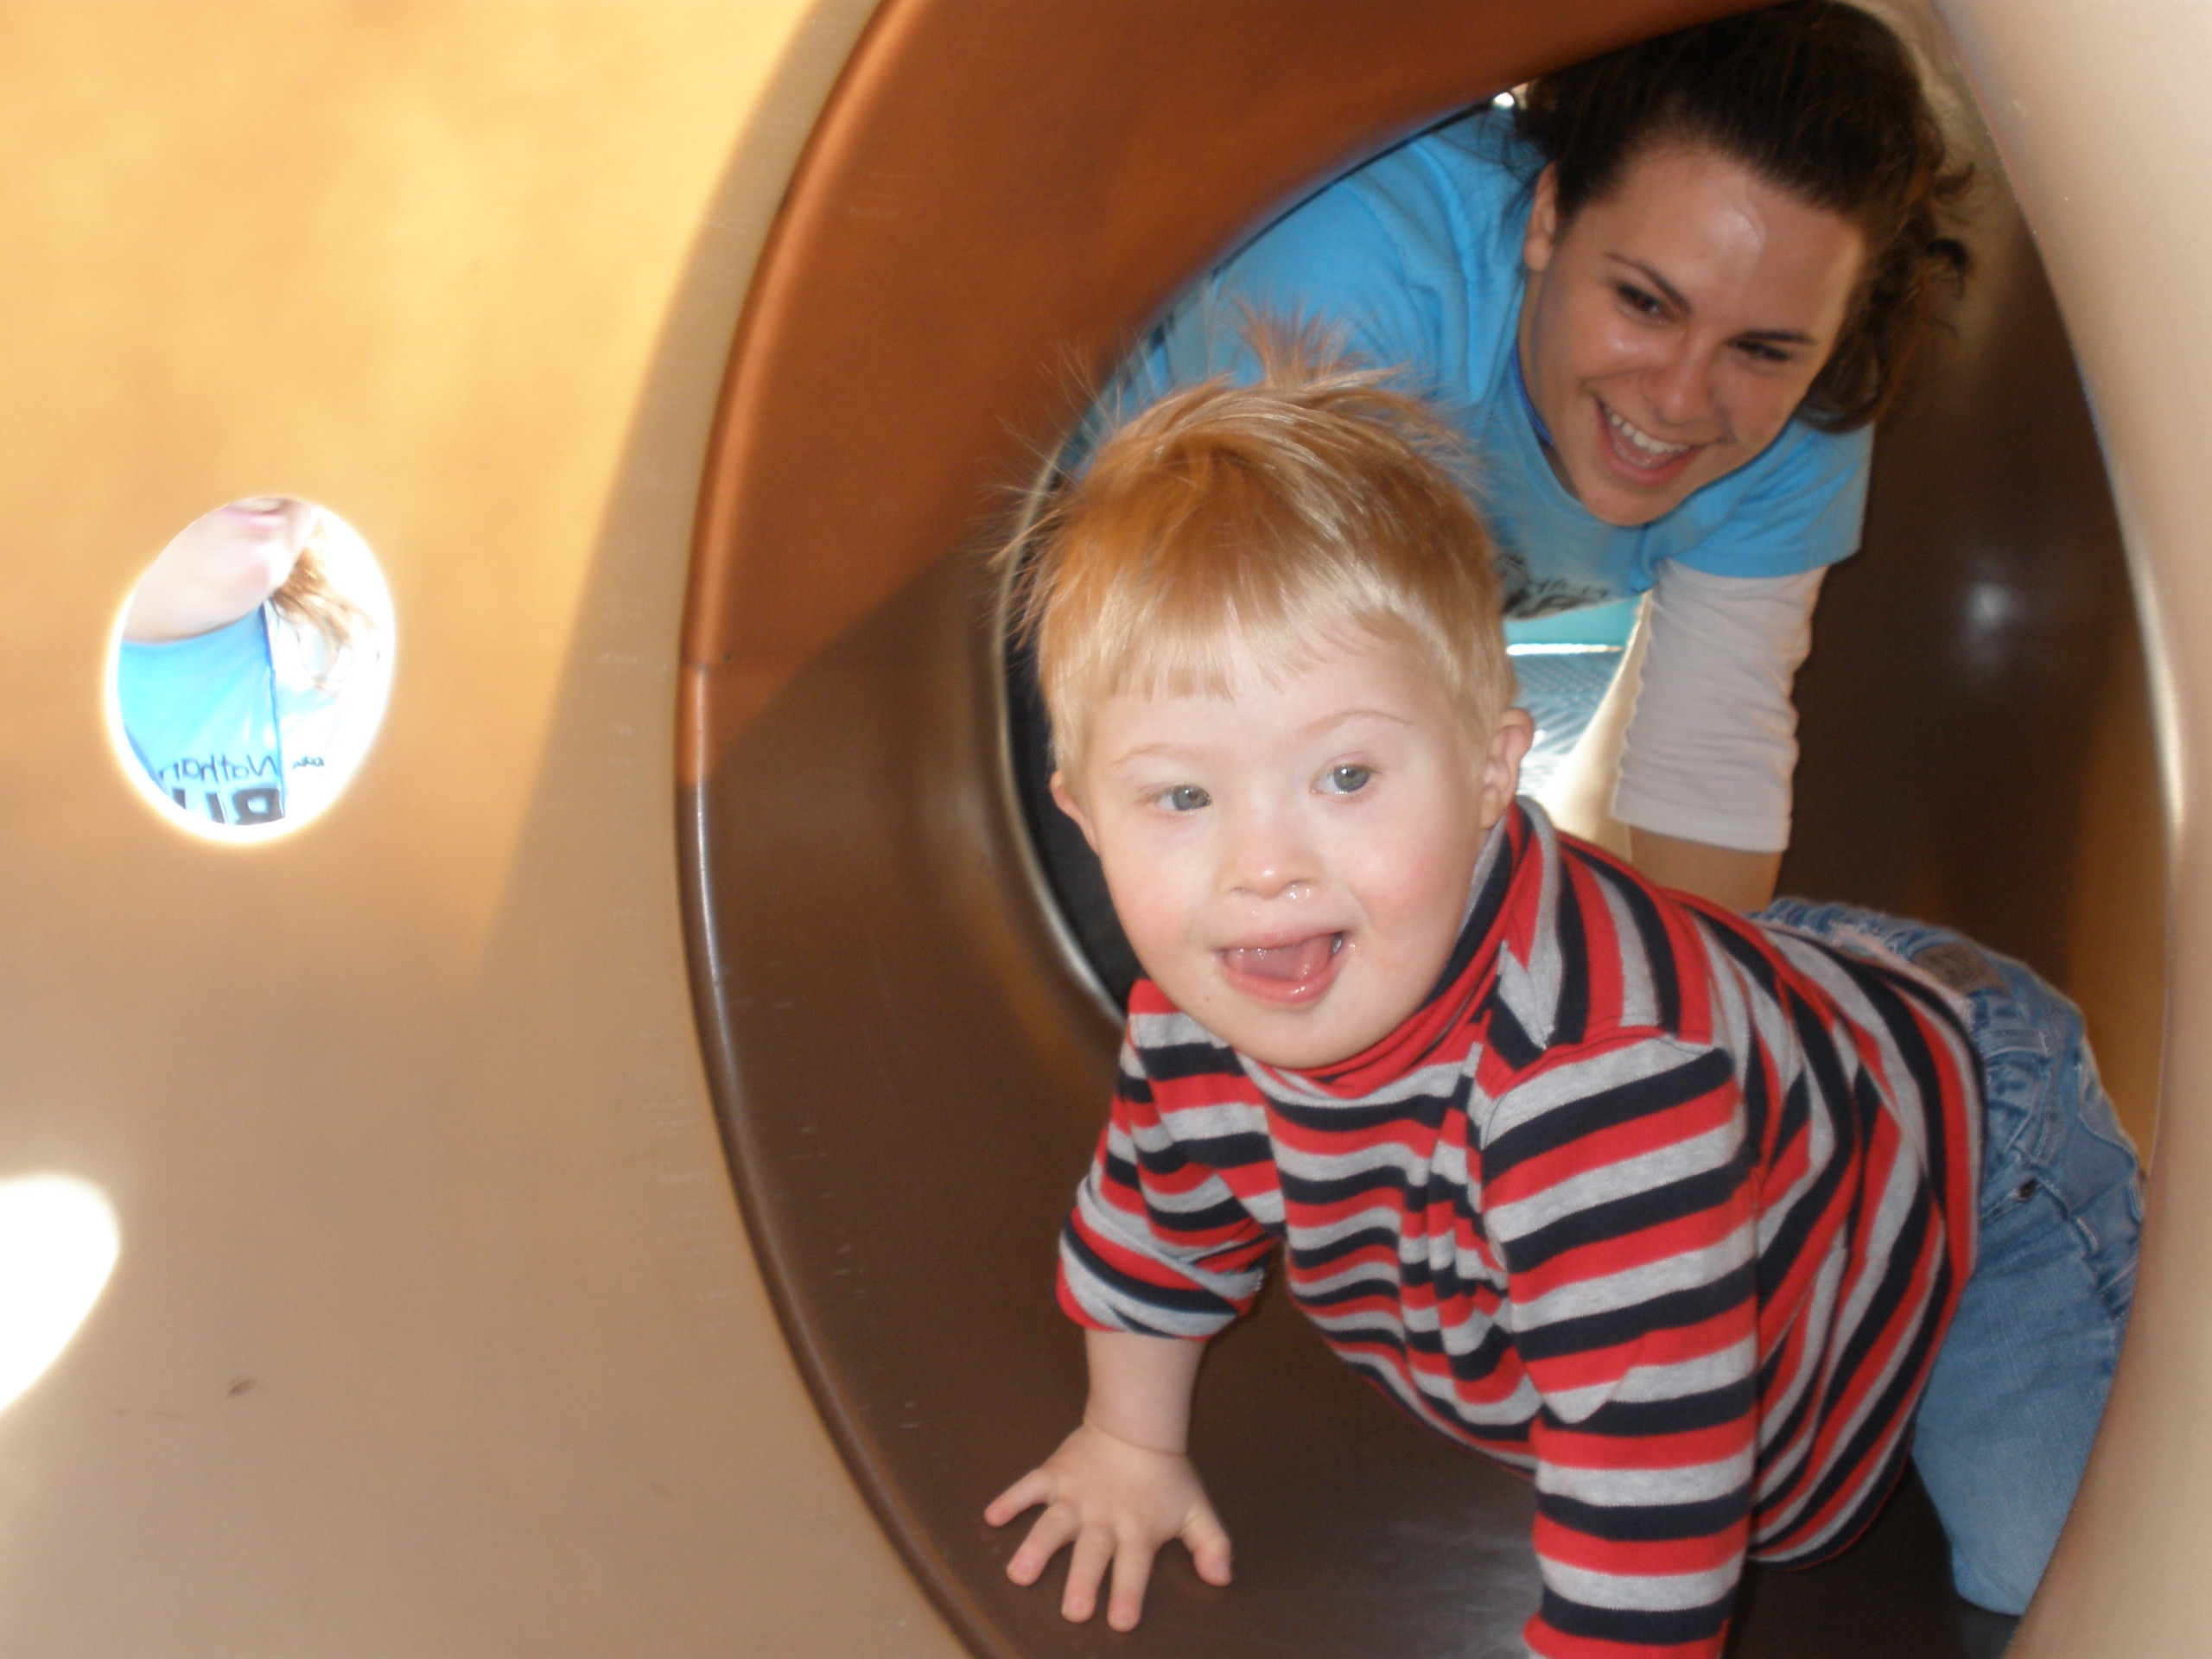  fun for kids  Giving caregivers  of kids with  special needs  a break!
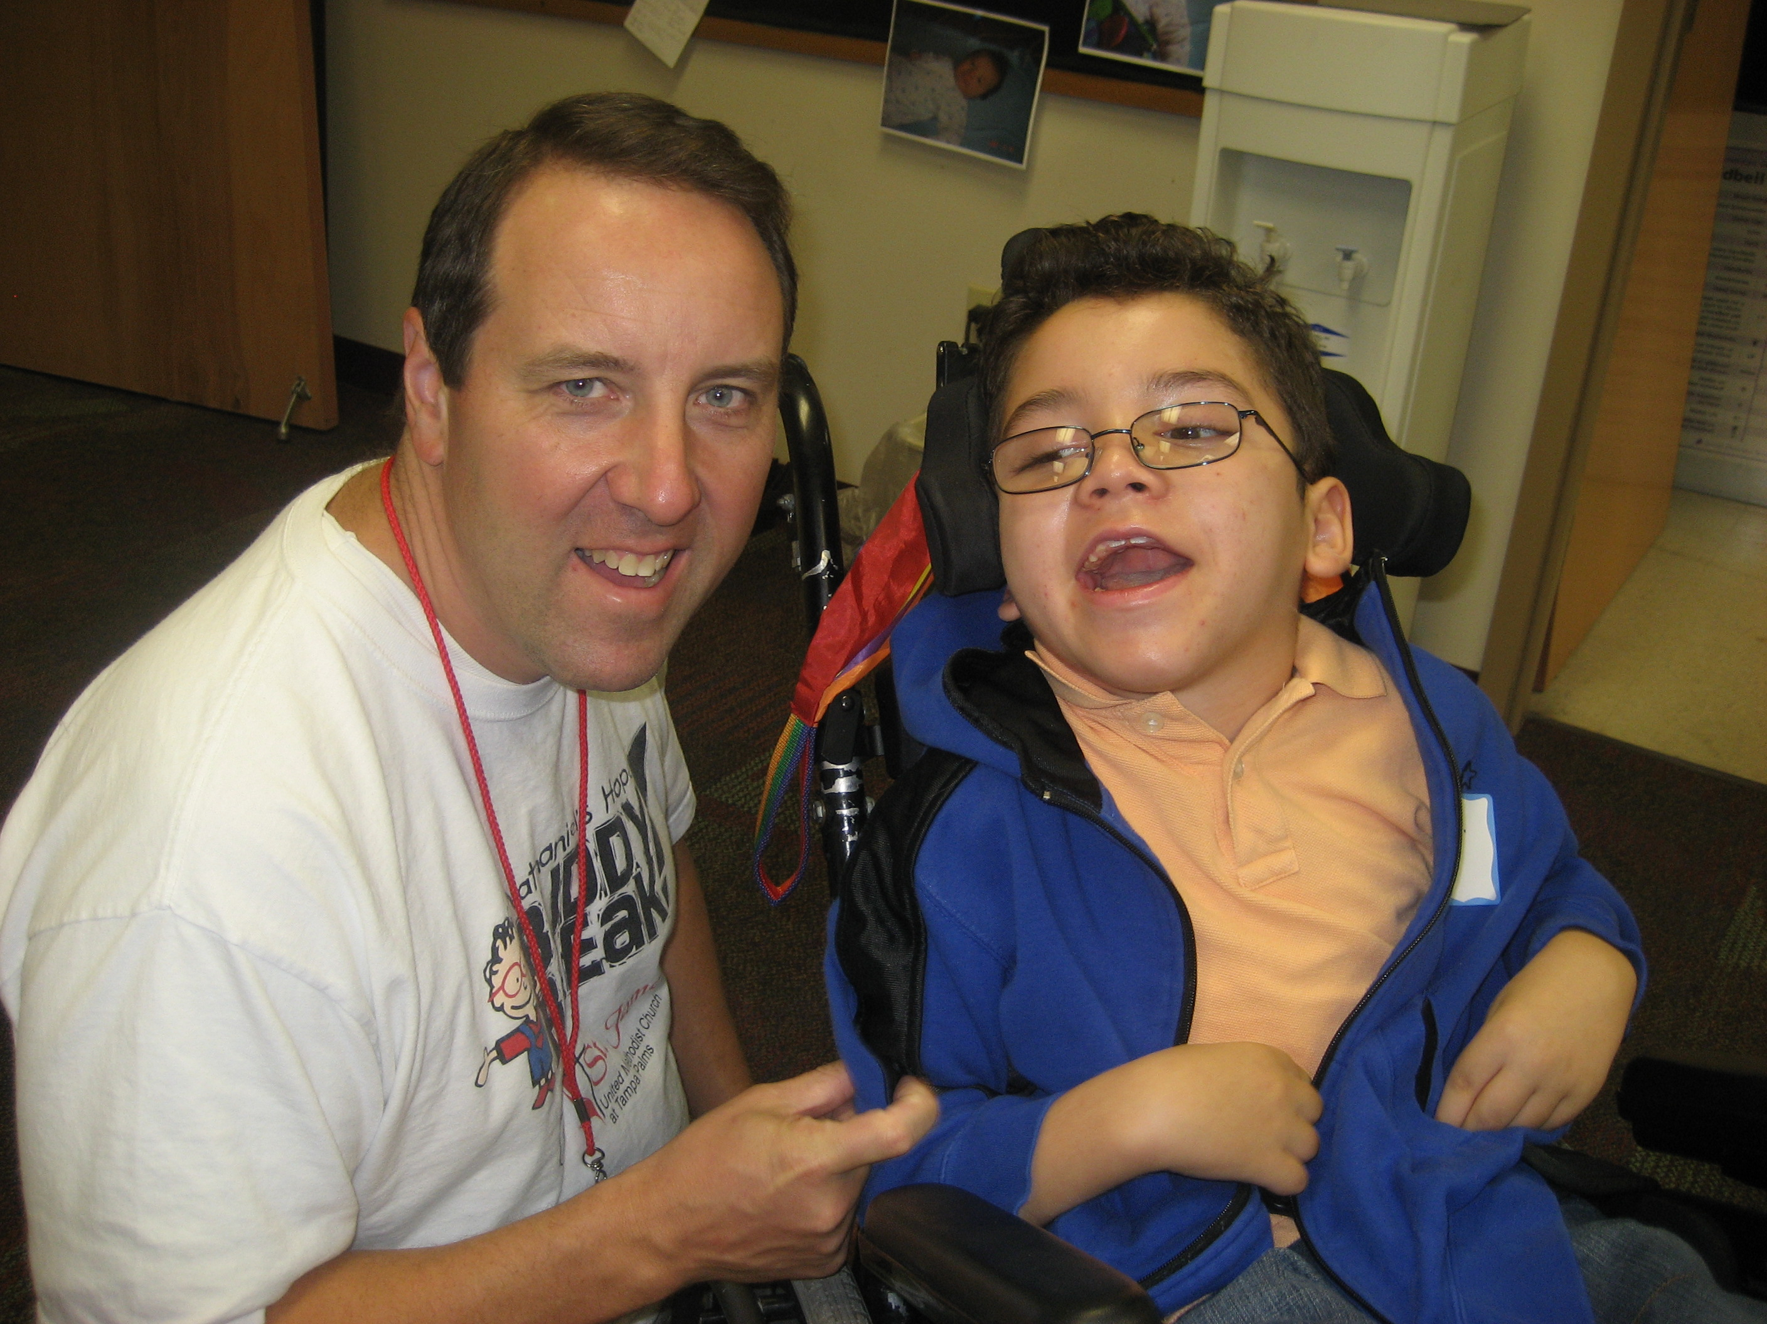  Who are VIP kids?  VIPs are kids with special needs, which include any physical, cognitive, medical or hidden disability, chronic or life-threatening illness, or those who are medically fragile.  Who are Buddies?  Buddies are friends of VIPs.  What is Buddy Break?  Buddy Break is a free kids/respite program where kids with special needs (VIP kids) make new friends, play fun games, enjoy crafts, therapy dogs, stories, music, activities and more! Siblings have fun too! Meanwhile, their caregivers get a break from their ongoing care-giving responsibilities for three hours one Friday night or one Saturday morning a month.  Why is there a need for Buddy Break?  The weight and stress of finding proper doctors, teachers, and financial resources for a VIP child’s care can be overwhelming. Those responsibilities, along with the never-ending demands of daily care-giving and life in general, leave little opportunity for caregivers to take time for themselves, run errands, or spend time with a spouse or other children—things desperately needed to survive. Buddy Break provides a safe place for VIPs and their siblings to have fun and establish meaningful friendships with other kids and adults while their caregivers get a break.  How do I sign up as a VIP?  This program is for VIP children birth ages: 2–16 years old, and their siblings:4 years old–5th grade. Some Buddy Break locations expand their program based on their ability to serve a wider age range.  To Sign Up:  1. Identify a location where you’d like to attend Buddy Break at www.BuddyBreak.org or call the Nathaniel’s Hope office.  2. Complete the secure VIP Family Info Form online.  3. Call your preferred location to reserve your space at a required VIP orientation. This allows the Buddies to meet you and your children and gives you a chance to see Buddy Break before you begin participating. Orientation is held monthly at each Buddy Break location.  How do I sign up to be a Buddy?  No previous experience with VIP kids is necessary to be a Buddy, just a loving heart, open arms, and a willingness to learn. Each VIP kid is paired one-on-one with a screened volunteer Buddy, who is at least 14 years of age and has completed a two-hour Buddy Training 101 class. Doctors, nurses, therapists, and special education teachers are also invited to participate.  As a Buddy, identify a Buddy Break location where you would like to serve — visit www.BuddyBreak.org for a list of locations or call the Nathaniel’s Hope office. Then contact your preferred location to schedule a visit. |     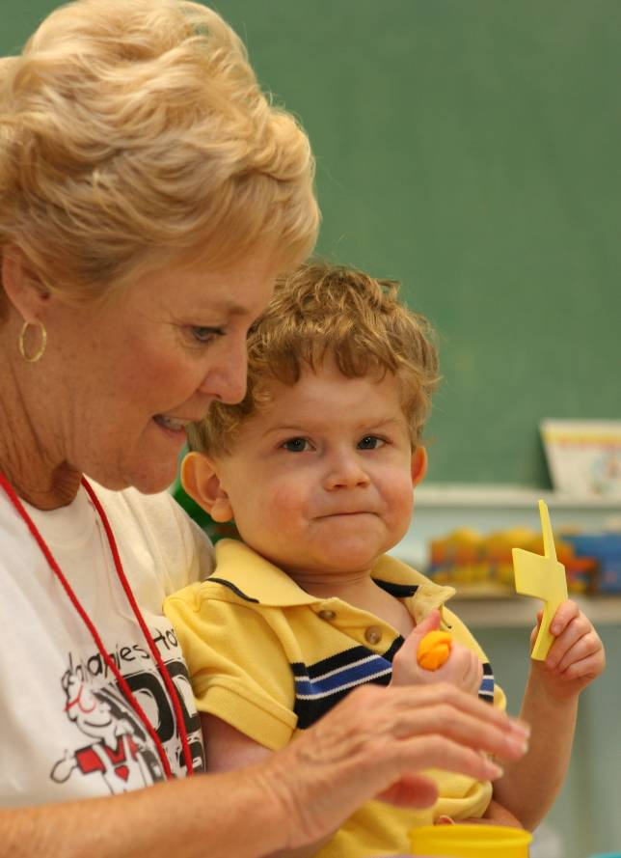  Nathaniel’s Hope is building a national network of churches and Buddies to serve VIP kids and their families. To see where our  expansion has taken us, visit our website. If you would like to start a Buddy Break program, please contact Nathaniel’s Hope  and we will provide your church with the training and tools to  make Buddy Break a fun, safe, and successful program!  Where is Buddy Break?  Buddy Break is a growing ministry to the VIP community done in partnership between Nathaniel’s Hope and local churches across the nation. Once a VIP attends orientation or  a volunteer becomes an official Buddy, he or she may  participate in any Buddy Break program anywhere by  calling the location to make a reservation. You can even participate in Buddy Break more than once a month.  “For I know the plans I have for you” declares the Lord… “to give you a future and a hope.”  -Jeremiah 29:11 |     www.NathanielsHope.org  “I will never be able to put into words how I came to the church broken and feeling that no one would be able to understand what a single mom  with a special needs child  goes through or even needs.  But, the Lord has totally  worked and used you all  to bring hope, encour-  agement, joy, love,  compassion, to  someone that has  been on this road  for a long time  and was getting  weary and  tired. I will  never be able  to thank you  enough.”  Tammy,  VIP Parent
“Buddy Break is such a gift for
my family! My kids have found a place where they fit right in, are cared for, and loved in ways that sometimes I, as an exhausted mom, just can’t do. My son with special needs has a wonderful time playing with his Buddy and his sibling gets to talk to other children “like me, with a special brother or sister.” Meanwhile, I have time to get a few things done, reconnect with friends, or even just sit still with a sense of peace so that I can be a stronger and better parent. Thank you so much for all you do. I am incredibly grateful!”
~ Lucette, VIP Parent

